

Cooperative Drone Swarm Search and Rescue Using Multi-Agent Reinforcement Learning and Swarm-Based Agent Simulation

A CAPSTONE PROJECT REPORT

A Capstone Project Report submitted in partial fulfilment of the requirements for the Course of

MLA0305-Reinforcement learning

to the award of the degree of

BACHELOR OF TECHNOLOGY IN
ARTIFICIAL INTELLIGENCE AND MACHINE LEARNING

Submitted by

N. PARNITA (192525322)
Under the Supervision of Dr. Vincent Gnanaraj T
SIMATS ENGINEERING
Saveetha Institute of Medical and Technical Sciences Chennai-602105
SEPTEMBER 2026

SIMATS ENGINEERING
Saveetha Institute of Medical and Technical Sciences Chennai-602105

BONAFIDE CERTIFICATE

This is to certify that the Capstone Project entitled “Cooperative Drone Swarm Search and Rescue Using Multi-Agent Reinforcement Learning and Swarm-Based Agent Simulation” has been carried out by N. PARNITA (192525322) under the supervision of Dr. Vincent Gnanaraj T and is submitted in partial fulfilment of the requirements for the current semester of the Bachelor of Technology In Artificial Intelligence And Machine Learning program at Saveetha Institute of Medical and Technical Sciences, Chennai.

COURSE COORDINATOR COURSE FACULTY
Dr. G A Senthil, Dr. Vincent Gnanaraj T,
Program Director, Associate Professor,
Department of Cloud Computing, Department of Quantum Intelligence,
SIMATS Engineering, SIMATS Engineering,
SIMATS, Chennai – 602105. SIMATS, Chennai – 602105.

SIMATS ENGINEERING
Saveetha Institute of Medical and Technical Sciences Chennai-602105

DECLARATION

I, N.Parnita of the AIML, SIMATS Engineering, Saveetha Institute of Medical and Technical Sciences, Chennai, hereby declare that the Capstone Project Work entitled “Cooperative Drone Swarm Search and Rescue Using Multi-Agent Reinforcement Learning and Swarm-Based Agent Simulation” is the result of our own bonafide efforts. To the best of our knowledge, the work presented herein is original, accurate, and has been carried out in accordance with the principles of engineering ethics and academic integrity. All sources, references, data, and other materials used in the project have been appropriately acknowledged. We further declare that the data, results, analysis, and findings presented in this report have not been fabricated, falsified, or manipulated. Any external tools, software, datasets, computational resources, or AI-assisted tools used during the project have been appropriately disclosed. We confirm that all applicable ethical, academic, institutional, and professional requirements have been duly followed throughout the planning, execution, analysis, and documentation of the project.

Place:
Date:

Signature of the Student with Name

N. PARNITA (192525322)

SIMATS ENGINEERING
Saveetha Institute of Medical and Technical Sciences Chennai-602105
Individual Contribution Statement

Student Name / Register No. | Specific  Responsibilities | Design & Development Contribution | Testing & Analysis  Contribution | Report Contribution | Approx.  Contribution (%)
P. Hithaishi  192425196 | Environment & drone initialization | Dataset generation, preprocessing, environment setup | Tested drone initialization and data | Introduction, Objectives, Module 1 | 34%
Student 2 – K. Sri Lasya / 192472216 | Swarm coordination & MARL | Swarm movement, Q-learning and coordination | Tested navigation and learning | Literature,  Methodology,  Module 2 & 3 | 33%
Student 3 – N. Parnita / 192525322 | Reward & performance evaluation | Reward calculation and metrics | Analysed rewards, paths and results | Results, Discussion, Conclusion | 33%
Total |  |  |  |  | 100%

ABSTRACT

Cooperative Drone Swarm Search and Rescue using Multi-Agent Reinforcement Learning and Swarm-Based Agent Simulation proposes an intelligent system for autonomous search and rescue operations using multiple cooperative drones. Traditional search methods and single-drone systems often face limitations such as limited area coverage, inefficient coordination, redundant exploration, and increased search time.

The proposed system integrates Multi-Agent Reinforcement Learning (MARL) with swarm-based simulation, allowing multiple drones to communicate, coordinate, and learn suitable actions for efficient navigation and target detection. Each drone operates as an independent learning agent while cooperating with other drones to maintain safe movement, avoid redundant exploration, and maximize search coverage. Swarm coordination is achieved using separation, cohesion, and alignment mechanisms.

The project consists of data generation and statistical analysis, data preprocessing, multi-agent drone swarm simulation, MARL-based training, and performance evaluation. The learning system uses reward-based decision-making to encourage target detection and search coverage while penalizing collisions and unnecessary energy consumption.

The system was evaluated using performance measures including average reward, maximum reward, average steps, final distance, and success rate. The trained drone swarm achieved an average reward of 217.86, maximum reward of 378.18, average steps of 15.50, final distance of 0.00, and a 100% success rate. The simulation also achieved an average final distance of 3.77 and a total reward of
601.12 for the configured simulation. These results demonstrate effective cooperative navigation and successful target reaching.

Overall, the proposed framework demonstrates the potential of combining MARL with swarm-based coordination for improving autonomous search and rescue operations.

Keywords

Multi-Agent Reinforcement Learning, Drone Swarm, Search and Rescue, Swarm Intelligence, UAV, Autonomous Navigation

TABLE OF CONTENTS

Sl.  No | Title | Page  No
i | CERTIFICATE FROM THE SUPERVISOR | 2
ii | DECLARATION BY THE CANDIDATE | 3
Iii | INDIVIDUAL CONTRIBUTION STATEMENT | 4
iv | ABSTRACT | 5
v | LIST OF FIGURES | 7
vi | LIST OF TABLES | 8
vii | LIST OF ABBREVIATIONS | 9
1 | CHAPTER 1: Introduction | 10-12
2 | CHAPTER 2: Literature Review | 13-15
3 | CHAPTER 3: Engineering Design & Trade-offs, Sustainability,  Ethics, Safety, Risk & Security | 16-25
4 | CHAPTER 4: Implementation, Testing & Results, Project  Management | 26-30
5 | CHAPTER 5: Conclusion & Reflection | 31-32
 | References | 33
 | Appendices | 34-37

LIST OF FIGURES

Figure No. | Figure Name | Page No.
Figure 1 | Cooperative Drone Swarm Search and Rescue Architecture | 20
Figure 2 | Proposed Methodology Flowchart | 21
Figure 3 | Cooperative Drone Swarm Movement Towards the Target | 28
Figure 4 | Performance Comparison of the Cooperative Drone Swarm | 34

LIST OF TABLES

Table  No. | Table Name | Page  No.
Table 1 | Comparative Analysis of Existing Approaches | 14
Table 2 | Stakeholder / User Requirements | 16
Table 3 | Functional & Non-Functional Requirements | 16–17
Table 4 | Constraints & Applicable Standards | 17–18
Table 5 | Design Specifications | 18
Table 6 | Alternative Solutions & Evaluation | 19
Table 7 | Trade-off Analysis | 23
Table 8 | Sustainability, Ethics, Safety & Security | 24
Table 9 | Risk Register | 24–25
Table 10 | Experimental Setup – Drone Simulation Data | 26
Table 11 | MARL Performance Results | 27–28
Table 12 | Performance Evaluation | 29
Table 13 | Comparison with Existing Approaches | 30
Table 14 | Experimental / Raw Data | 35
Table 15 | Individual Contribution Evidence | 37

LIST OF ABBREVIATIONS / SYMBOLS

Symbol | Description | Unit
Symbol | Description | Unit
UAV | Unmanned Aerial Vehicle | —
MARL | Multi-Agent Reinforcement Learning | —
RL | Reinforcement Learning | —
SAR | Search and Rescue | —
AI | Artificial Intelligence | —
ML | Machine Learning | —
DRL | Deep Reinforcement Learning | —
CSV | Comma-Separated Values | —
E | Search Environment | —
D | Set of Drones | —
T | Target Locations | —
O | Obstacles | —
Bᵢ | Battery level of drone Dᵢ | —
Rᵢ | Sensor range of drone Dᵢ | —
Pᵢ(t) | Position of drone Dᵢ | —
Vᵢ(t) | Velocity of drone Dᵢ | —
Oᵢ(t) | Local observation of drone Dᵢ | —
Fsep | Separation force | —
Fcoh | Cohesion force | —
Falign | Alignment force | —
Q(s,a) | Quality value for state s and action a | —
α | Learning rate | —
γ | Discount factor | —

CHAPTER 1

INTRODUCTION AND ENGINEERING PROBLEM

Background

Search and rescue operations often require quick and efficient exploration of large or unknown areas. Traditional search methods and single-drone systems may provide limited coverage and require more time to locate targets.

Cooperative drone swarms provide an effective approach by using multiple autonomous drones that can work together to explore an environment. Multi-Agent Reinforcement Learning (MARL) enables multiple drones to learn and make decisions collaboratively, while swarm-based agent simulation supports coordination, communication, collision avoidance, and collective movement.

In the proposed system, each drone acts as an independent learning agent and selects suitable actions according to its current state and surrounding environment. Separation, cohesion, and alignment mechanisms are used to maintain safe and coordinated swarm movement. A cooperative reward system encourages search coverage and target detection while penalizing collisions and excessive energy consumption.

Need for the Project
Existing single-drone and conventional search approaches may suffer from: Limited search area coverage
Inefficient path planning Redundant exploration
Poor coordination between drones Increased search time
Unnecessary movement and energy consumption
When multiple drones operate without proper cooperation, they may repeatedly search the same areas or move inefficiently. Therefore, an intelligent cooperative system is required to coordinate multiple drones, maximize search coverage, improve target detection, and reduce unnecessary movement and energy consumption.

Problem Statement
Existing search and rescue systems and single-drone approaches suffer from limited coverage, inefficient coordination, redundant exploration, poor path planning, and increased search time.

Therefore, there is a need for an intelligent cooperative drone swarm system using Multi-Agent Reinforcement Learning and swarm-based agent simulation to improve coordination, maximize search area coverage, optimize navigation, improve target detection, and enhance search and rescue efficiency.

Project Aim
To develop an intelligent cooperative drone swarm system using Multi-Agent Reinforcement Learning and swarm-based agent simulation for autonomous search and rescue operations, with improved coordination, search coverage, target detection, and navigation efficiency.

Project Objectives
To develop a cooperative drone swarm system using Multi-Agent Reinforcement Learning (MARL) for autonomous search and rescue operations.
To implement swarm-based coordination for efficient communication, task allocation, path planning, and maximum search area coverage among multiple drones.
To improve target detection accuracy, reduce search time, and enhance the overall efficiency and reliability of cooperative drone swarm missions.

Scope Included
Cooperative multi-drone search and rescue simulation Multi-Agent Reinforcement Learning
Swarm coordination Drone state representation Target detection
Search coverage evaluation Reward-based learning Drone movement simulation Performance evaluation
Statistical analysis and visualization

Excluded / Current Boundary
The current project is based on a simulation environment and does not demonstrate deployment on physical drones or a real-world search-and-rescue mission.

The current implementation uses configurable simulation parameters such as the number of drones, simulation steps, target coordinates, grid size, learning rate, discount factor, and exploration rate.

Expected Engineering Outcome
The expected outcome is an intelligent multi-agent drone swarm simulation capable of: Cooperative navigation
Target reaching
Improved search coverage Target detection
Coordinated swarm movement Reward-based learning
Performance evaluation using quantitative metrics
The developed system demonstrates successful target reaching with a 100% success rate and final distance of 0.00 in the reported trained-drone evaluation.

CHAPTER 2

LITERATURE REVIEW AND EXISTING SOLUTIONS

Review Method

The literature survey considered research related to:

Multi-Agent Reinforcement Learning Deep Reinforcement Learning
UAV search and rescue Multi-UAV coordination Swarm robotics
UAV communication Cooperative path planning
Autonomous target search and tracking

Review of Existing Work

- Hickling et al. (2026)
Paper: Deep Reinforcement Learning Based Autonomous Decision-Making for Cooperative Uncrewed Aerial Vehicles: A Search and Rescue Real World Application
The study developed a deep reinforcement learning framework for cooperative UAVs supporting autonomous navigation, task allocation, and victim search in real-world search-and-rescue missions.

- Chen et al. (2026)
Paper: Multi-stage Hierarchical Multi-Agent Reinforcement Learning for UAV-Quadruped Completing Search and Rescue
The research proposed a hierarchical MARL architecture allowing UAVs and ground robots to cooperate during search-and-rescue operations, improving coordination and exploration.

- Liu et al. (2024)
Paper: A Two-Stage Target Search and Tracking Method for UAV Based on Deep Reinforcement Learning
The research introduced a two-stage deep reinforcement learning method for UAV target search and tracking, improving navigation accuracy and target-following performance.

- Sadhu et al. (2024)
Paper: Aerial-Deep Search: Distributed Multi-Agent Deep Reinforcement Learning for Search Missions
The work presented a distributed multi-agent deep reinforcement learning framework that allows multiple UAVs to cooperate while exploring unknown environments.

- Han et al. (2024)
Paper: Joint Association, Deployment and Flight Trajectory Optimization for Multi-UAV Enabled Large-Scale Mobile Edge Computing
The research focused on optimized UAV deployment and trajectory planning to improve communication efficiency and cooperative mission performance.

Comparative Analysis

Existing Approach | Advantages | Limitations / Gap | Relevance
Single-drone search | Simple operation | Limited coverage and increased search time | Motivates multi-drone approach
Deep RL-based UAV search | Autonomous decision-making | Primarily focuses on individual/cooperative  UAV learning | Supports RL-based navigation
Hierarchical MARL | Improved multi-agent  coordination | More complex architecture | Supports MARL  cooperation
Distributed MARL | Cooperative exploration | Requires coordination and  information sharing | Closely related to  proposed system
Swarm robotics | Decentralized collective  behaviour | Coordination mechanisms  required | Supports swarm-based  movement
UAV trajectory optimization | Improved path planning | Focus may be application-specific | Supports optimized drone movement

Research / Engineering Gap

The reviewed studies demonstrate the usefulness of reinforcement learning, multi-agent cooperation, UAV coordination, swarm intelligence, and path planning.
The proposed project brings these concepts together in a cooperative drone swarm simulation by integrating MARL with swarm-based coordination, including separation, cohesion, alignment, information sharing, reward-based learning, and performance evaluation.

Proposed Contribution

The project proposes a cooperative drone swarm framework in which multiple drones operate as learning agents while coordinating their movement through swarm-based mechanisms.

The framework focuses on:

    - Cooperative navigation
    - Search area coverage
    - Target detection
    - Swarm coordination
    - Collision avoidance
    - Reward-based learning
    - Performance evaluation

The architecture connects the search environment, MARL module, swarm coordination module, optimized drone movement, and performance evaluation.

CHAPTER 3

ENGINEERING DESIGN & TRADE-OFFS, SUSTAINABILITY, ETHICS, SAFETY, RISK & SECURITY

Requirements
Stakeholder / User Requirements
The proposed system is designed to support autonomous search and rescue operations using multiple cooperative drones. The main requirements are efficient exploration of large or unknown search areas, improved coordination among drones, reduced redundant exploration, faster target detection, and effective target reaching. The simulation user should also be able to configure important parameters such as the number of drones, simulation steps, target coordinates, training episodes, grid size, learning rate, discount factor, and exploration rate.

Stakeholder | Requirement
Search and Rescue Operation | Efficient exploration of large or unknown search areas
Simulation User | Configure the number of drones, simulation steps, and target coordinates
Drone Swarm | Coordinate movement and share relevant information among neighbouring drones
Reinforcement Learning System | Enable drones to learn suitable actions for cooperative navigation
Mission Evaluation | Evaluate search performance using reward, steps, final distance, and success rate

Functional & Non-Functional Requirements
Requirement | Type (Functional/Non-Functional) | Measurable Target
Simulate multiple autonomous drones | Functional | Multiple drones operate within the search environment
Configure drone swarm | Functional | Number of drones can be configured
Configure search environment | Functional | Search area, obstacles, and target locations can be defined
Coordinate drone movement | Functional | Separation, cohesion, and alignment mechanisms are applied

Share relevant information | Functional | Drones share information with neighbouring drones
Apply MARL | Functional | Each drone acts as an independent learning agent
Calculate cooperative reward | Functional | Coverage, target detection, collision and energy components are considered
Detect and reach target | Functional | Target detection and target-reaching performance are recorded
Measure search performance | Functional | Reward, search steps, final distance, and success rate are evaluated
Support configurable training | Functional | Training episodes, grid size, learning rate, discount factor, and exploration rate can be  configured
Reduce redundant exploration | Non-Functional | Cooperative movement should minimize repeated exploration
Improve search efficiency | Non-Functional | Search time and unnecessary movement should be reduced
Maintain safe swarm movement | Non-Functional | Collision avoidance is supported through swarm coordination
Scalability | Non-Functional | The system supports a configurable number of drones
Reliable evaluation | Non-Functional | Performance is evaluated using defined simulation metrics
The functional and non-functional requirements are derived from the project's stated methodology, configurable simulation parameters, swarm coordination mechanism, MARL approach, and performance evaluation metrics.

Constraints & Applicable Standards
The current project is implemented as a swarm-based simulation rather than a physical drone deployment. Therefore, the design is constrained by the simulation environment and the parameters used for training and evaluation. The number of drones, simulation steps, target coordinates, grid size, training episodes, learning rate, discount factor, and exploration rate can be configured.
The project sources do not identify a specific engineering standard or regulatory code that was applied to the implemented simulation. Therefore, no specific standard is claimed here.

Standard / Code | Requirement | How Applied in This Project
No specific standard | No specific engineering or | The project is implemented and evaluated

identified in the project  sources | regulatory standard is stated | as a simulation-based cooperative drone  swarm system
The major technical constraints identified from the project are the dependence on simulation parameters and the difference between simulated drone behaviour and real-world drone operation. The future scope specifically identifies the need for more realistic collision avoidance, communication, energy constraints, larger areas, dynamic obstacles, and real-world datasets.

Design Specifications
The design specifications are based on the system architecture, proposed methodology, configurable simulation parameters, drone state representation, swarm coordination mechanism, and evaluation measures described in the project.
Parameter | Target/Requirement | Unit | Priority
Number of drones | Configurable multiple drones | Number of drones | High
Search environment | Predefined search area | Search area | High
Obstacles | Included in the environment | Position | High
Target locations | Configurable target coordinates | Coordinates | High
Drone position | Pi(t) = (xi, yi) | Coordinates | High
Drone velocity | Maintained during simulation | Velocity | Medium
Battery level | Included in drone state | Battery level | Medium
Sensor range | Defined for each drone | Range | Medium
Local observation | Available to each drone | State information | High
Learning rate | Configurable | α | High
Discount factor | Configurable | γ | High
Exploration rate | Configurable | Rate | Medium
Search coverage | Maximize explored area | Percentage | High
Target detection | Maximize detected targets | Percentage | High
Collision | Minimize collision occurrence | Count | High
Energy consumption | Minimize unnecessary consumption | Energy | Medium
Final distance | Minimize distance to target | Distance | High
Success rate | Maximize successful target reaching | Percentage | High
The drone state includes position, velocity, battery level, sensor range, and local observation. The system also uses separation, cohesion, and alignment forces for coordinated swarm movement.

Alternative Solutions & Evaluation
Alternative 1: Single-Drone Search

A single-drone approach performs the search using one autonomous drone. It provides a simpler search process but has limited coverage and can require more time for large or unknown search areas.
Alternative 2: Conventional Multi-Drone Search
A conventional multi-drone approach uses multiple drones to explore the environment. It can provide wider exploration, but without suitable cooperative learning and coordination, drones may perform redundant exploration or move inefficiently.
Alternative 3: MARL-Based Cooperative Drone Swarm
The proposed approach combines multiple autonomous drones with Multi-Agent Reinforcement Learning and swarm-based coordination. Each drone acts as an independent learning agent while separation, cohesion, alignment, information sharing, and cooperative rewards support coordinated navigation and search.
The original project sources do not provide numerical weights or numerical ratings for the alternatives. Therefore, no artificial weighting or scoring values are introduced below.
Criterion | Weight | Alternative 1 | Alternative 2 | Alternative 3
Performance | Not specified | Limited by single drone | Improved through multiple drones | Improved through MARL and cooperation
Cost | Not specified | Single-drone system | Multiple drones | Multiple simulated learning agents
Safety | Not specified | Individual movement | Requires coordination | Collision avoidance through swarm coordination
Sustainability | Not specified | Limited cooperative  optimization | Depends on coordination | Energy consumption included in reward
Reliability | Not specified | Limited coverage | Dependent on coordination | Learning and cooperative behaviour support mission  performance
Based on the documented project approach, Alternative 3 is selected because it directly addresses the identified limitations of single-drone and conventional search approaches by combining MARL with swarm-based coordination.

Selected Design & Detailed Design
The selected design is the Cooperative Drone Swarm Search and Rescue system using Multi-Agent Reinforcement Learning and Swarm-Based Agent Simulation. The selection is based on the requirement to improve coordination, maximize search coverage, reduce redundant exploration, improve target detection, and reduce search time. The project integrates multiple autonomous drones, MARL, swarm coordination, and cooperative reward calculation into a single simulation framework.

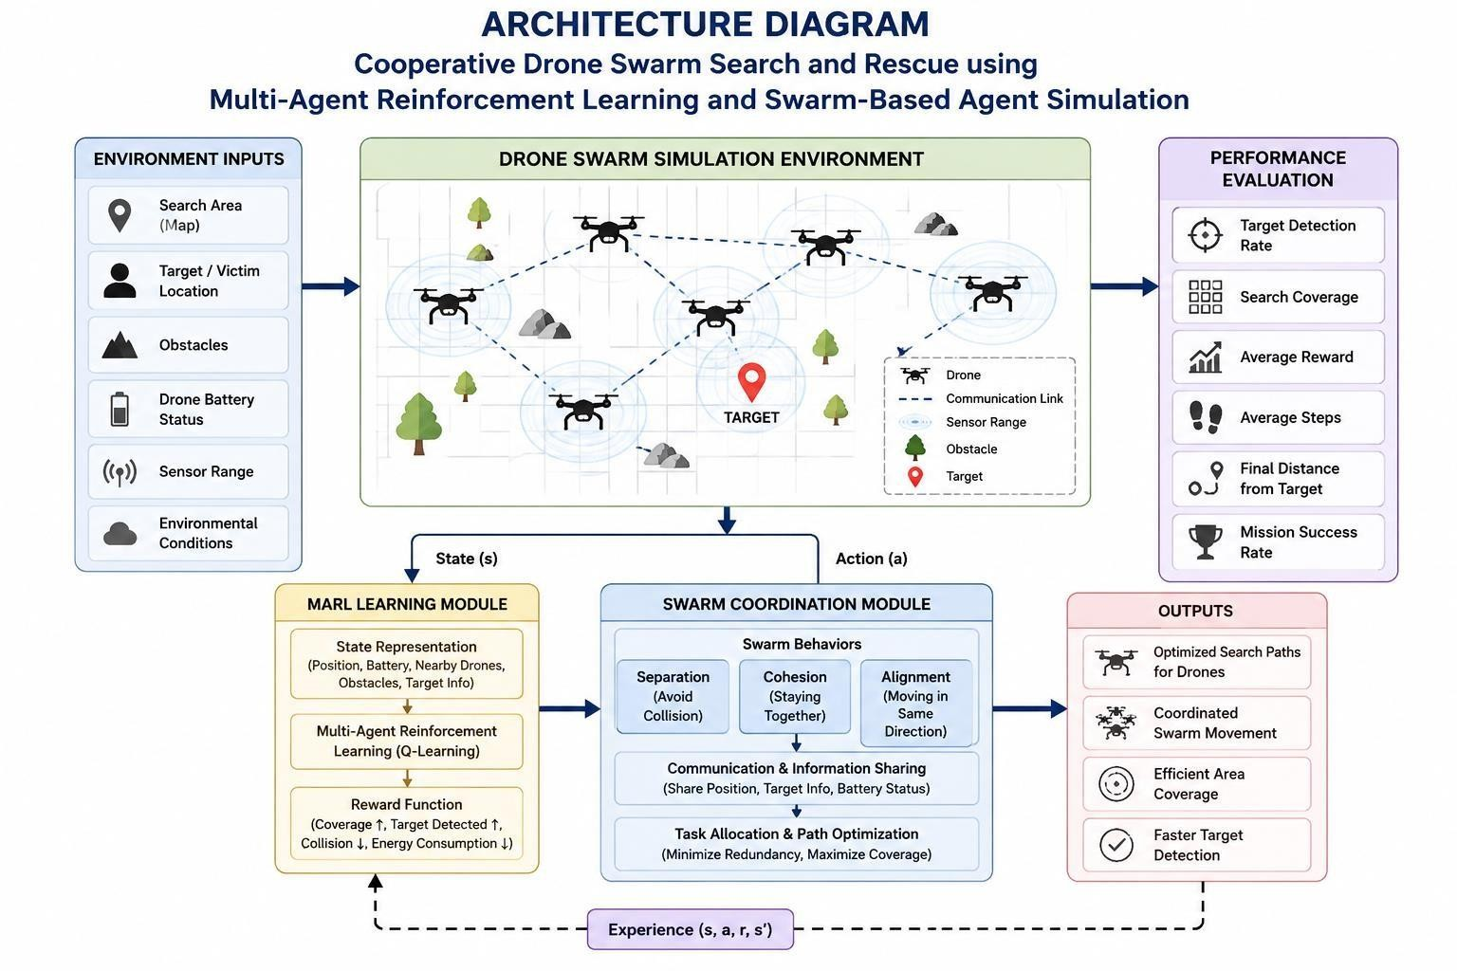
Figure 3.1: Cooperative Drone Swarm Search and Rescue Architecture
The architecture consists of the search environment, drone swarm, MARL module, swarm coordination mechanism, and performance evaluation. The search environment provides information to the drone swarm for exploration. The MARL module enables drones to select suitable actions based on their current state and rewards, while the swarm coordination module supports separation, cohesion, alignment, and information sharing. The system generates search paths and evaluates performance using coverage, target detection, reward, and success rate.

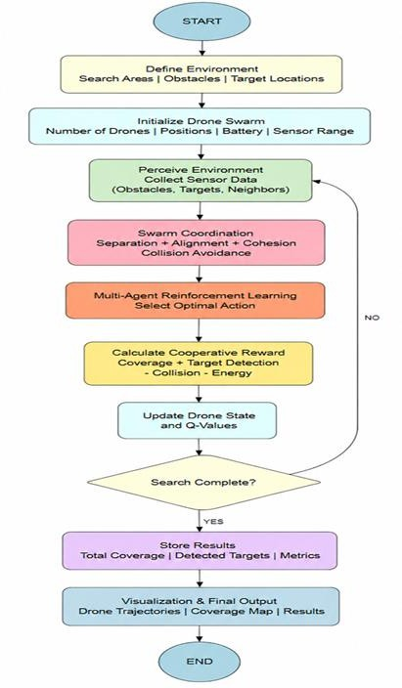
Figure 3.2: Proposed Methodology Flowchart
Define Environment → Initialize Drone Swarm → Swarm Coordination & MARL → Reward & State Update → Search & Output
The methodology begins by defining the search environment, including the search area, obstacles, and target locations. The drone swarm is then initialized with parameters such as the number of drones, positions, battery, and sensor range. Swarm coordination and MARL are applied to select suitable actions, after which rewards and drone states are updated. The process is repeated until completion, after which the trajectories, coverage map, and performance results are produced.
The main design components are described below.

The search environment represents a predefined search area containing obstacles and target locations. It provides the environment in which the drones perform cooperative exploration.
Each drone is represented as an independent learning agent. Its state includes position Pi(t) = (xi, yi), velocity Vi(t), battery Bi(t), sensor range Ri, and local observation Oi(t). Each drone receives local environmental information and shares relevant information with neighbouring drones.
The swarm coordination mechanism controls cooperative drone movement using separation, cohesion, and alignment forces. Separation supports collision avoidance, cohesion supports collective movement, and alignment supports coordinated swarm behaviour. These mechanisms enable the drones to maintain formation and explore the search region cooperatively.
The MARL module allows each drone to act as an independent learning agent. The agents learn suitable actions through interaction with the environment and update their Q-values using the current state, selected action, reward, next state, learning rate, and discount factor. The learned behaviour supports navigation, target search, and task allocation.
The cooperative reward mechanism encourages desirable swarm behaviour. The reward considers search coverage, target detection, collision penalties, and energy consumption penalties. Therefore, the learning process encourages greater coverage and target detection while reducing collisions and unnecessary energy consumption.
Search coverage is calculated using:
Search Coverage (%) = (Asearched / Atotal) × 100
where Asearched represents the area searched by the drone swarm and Atotal represents the total search area.
Target detection rate is calculated using:
Target Detection Rate (%) = (Ndetected / Ntargets) × 100
where Ndetected represents the number of detected targets and Ntargets represents the total number of targets. A higher search coverage percentage indicates more effective exploration of the search region.

Systems Approach
The search environment, drone swarm, MARL module, swarm coordination module, and performance evaluation module operate as interconnected parts of the system. The environment provides state information to the drones, while the MARL module uses this information to select suitable actions. The swarm coordination mechanism supports cooperative movement and information sharing between drones. The resulting drone behaviour is evaluated using performance measures such as reward, search

steps, final distance, and success rate.

Trade-off Analysis
The design decisions involve balancing cooperative performance with system complexity. The following trade-offs are derived from the design choices documented in the project.
Design Decision | Alternative Considered | Benefit | Disadvantage | Final Decision & Justification
Multiple drones | Single-drone search | Wider area can be explored cooperatively | Requires coordination between drones | Multiple drones selected because the project aims to improve coverage and reduce search  time
MARL | Conventional movement/search | Enables agents to learn suitable actions | Requires training and parameter  configuration | MARL selected to support adaptive cooperative  navigation
Swarm coordination | Independent drone movement | Supports formation, collision avoidance, and cooperative exploration | Adds coordination mechanisms | Separation, cohesion, and alignment selected for coordinated  swarm behaviour
Cooperative reward | Individual action-based reward | Encourages coverage and target detection while penalizing collisions and energy  consumption | Reward calculation is more complex | Cooperative reward selected to align learning with mission objectives
Simulation | Immediate physical deployment | Provides a configurable environment for development and  evaluation | Does not represent all real-world conditions | Simulation selected for the current project
The final design therefore prioritizes cooperative search performance, adaptive learning, coordinated movement, and measurable simulation-based evaluation.

Sustainability, Ethics, Safety, Risk & Security
The project addresses sustainability, safety, and security considerations through the design of the cooperative reward and swarm coordination mechanisms. However, the project sources do not report

a separate experimental evaluation of ethics or cybersecurity mechanisms. Therefore, these areas are presented only to the extent supported by the project design.

Domain | Consideration | Evidence Evaluated | Impact on Final Decision
Sustainability | Reduce unnecessary energy consumption | Energy consumption is included as a penalty in the cooperative reward | The design encourages efficient movement and reduces unnecessary energy  consumption
Ethics | Responsible autonomous search behaviour | The current work is a simulation-based system and does not involve  human subjects | Ethical evaluation is limited to the simulation context
Health & Safety | Avoid collisions between drones | Separation mechanism is used along with cohesion  and alignment | Swarm coordination is included to support safe and coordinated  movement
Security | Information sharing between drones | Relevant information is shared among neighbouring drones | Information sharing supports coordination, but specific cybersecurity mechanisms are not implemented in the reported  system
The project specifically identifies collision avoidance and energy consumption as important factors in the cooperative reward and swarm coordination design. The future scope also identifies realistic communication, collision avoidance, and energy constraints as areas for further development.

Risk Register
Risk | Likelihood | Severity | Risk Level | Mitigation | Residual Risk
Drone collision during cooperative  movement | Not specified in source | Not specified in source | Not specified in source | Use separation force and swarm coordination | Requires further realistic validation
Redundant exploration | Not specified in source | Not specified in source | Not specified in source | Use information sharing and cooperative  learning | Reduced through cooperative behaviour
Excessive energy consumption | Not specified in source | Not specified in source | Not specified in source | Include energy consumption penalty in reward | Requires further evaluation under realistic energy  constraints

Inefficient navigation | Not specified in  source | Not specified  in source | Not specified  in source | Use MARL to learn suitable  actions and paths | Depends on training  configuration
Communication limitations | Not specified in source | Not specified in source | Not specified in source | Share relevant information between neighbouring  drones | Realistic communication constraints remain future work
Real-world deployment uncertainty | Not specified in source | Not specified in source | Not specified in source | Extend the simulation with realistic environments  and constraints | Physical deployment is outside the current implementation
The current project demonstrates the design and evaluation of a cooperative drone swarm in simulation. The project identifies realistic collision avoidance, communication constraints, energy constraints, dynamic obstacles, larger search areas, and real-world datasets as future extensions.

CHAPTER 4

IMPLEMENTATION, TESTING & RESULTS, PROJECT MANAGEMENT

Experimental Setup
The cooperative drone swarm simulation was performed using multiple drones to evaluate cooperative movement and target-reaching behaviour. The simulation environment consists of multiple drones operating towards a target position. The number of drones, simulation steps, and target coordinates can be configured before starting the simulation.
For the sample simulation, the system was configured with 5 drones and 50 simulation steps. The simulation records include parameters such as drone ID, battery, speed, target distance, and status. The simulation was used to observe the movement of the drones and their ability to reach the target cooperatively.

Iteration | Drone  ID | Battery | Speed | Target  Distance | Status
1 | 1 | 75.18 | 36.03 | 31.06 | Target  Detected
2 | 2 | 45.26 | 60.95 | 82.45 | Searching
3 | 3 | 51.84 | 40.50 | 47.03 | Target  Detected
4 | 4 | 38.45 | 80.42 | 32.87 | Target  Detected
5 | 5 | 46.18 | 71.23 | 12.57 | Searching

The simulation achieved an average final distance of 3.77 and a total reward of 601.12, indicating effective cooperative movement towards the target.

Simulation Results

The multi-agent drone swarm simulation demonstrates the cooperative movement of multiple drones towards the target position. The drones operate simultaneously and their movement is visualized to observe the behaviour of the swarm and its ability to reach the target.
The simulation demonstrates that multiple drones can navigate towards a target while operating as a cooperative swarm. The configurable simulation environment allows different numbers of drones, simulation steps, and target coordinates to be used for evaluation.

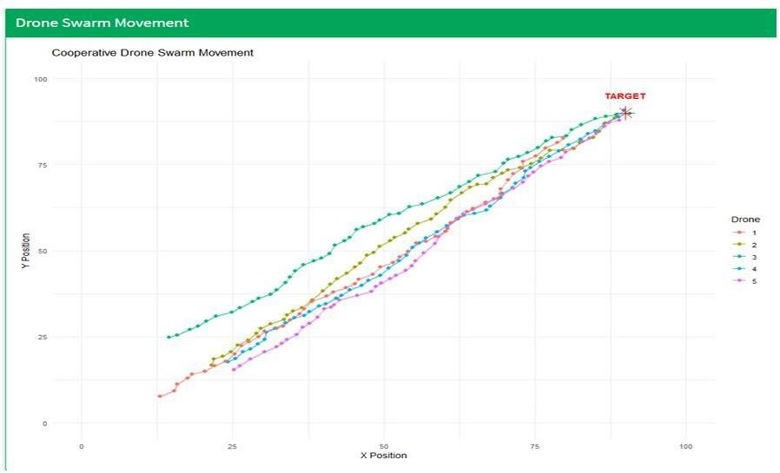
Figure 4.1: Cooperative Drone Swarm Movement Towards the Target

The figure shows the movement paths of five drones as they cooperatively navigate towards the target position. The paths indicate that the drones gradually move closer to the target while maintaining coordinated movement. This demonstrates the effectiveness of the swarm simulation in achieving cooperative navigation and target reaching.

Multi-Agent Reinforcement Learning Results

The Multi-Agent Reinforcement Learning module was used to train multiple drones for cooperative navigation. The training process allows the agents to learn suitable paths through repeated interaction with the environment.
The training parameters include the number of drones, training episodes, grid size, learning rate, discount factor, and exploration rate. The training reward is analysed to observe the learning performance of the agents.

The trained drone swarm achieved the following performance:

Performance  Metric | Value | Observation
Average Reward | 217.86 | Indicates the overall reward achieved by the  agents

Average Steps | 15.50 | Shows the average number of steps taken to  reach the target
Final Distance | 0.00 | Indicates that the drones reached the target  position
Maximum Reward | 378.18 | Represents the highest reward achieved during  training
Success Rate | 100% | Shows successful completion of the target-  reaching task

The results indicate that the trained drone agents learned effective cooperative navigation behaviour. The final distance of 0.00 and success rate of 100% show that the trained agents successfully reached the target position. The average reward of 217.86 and maximum reward of
378.18 indicate effective learning behaviour, while the average of 15.50 steps shows efficient target navigation.
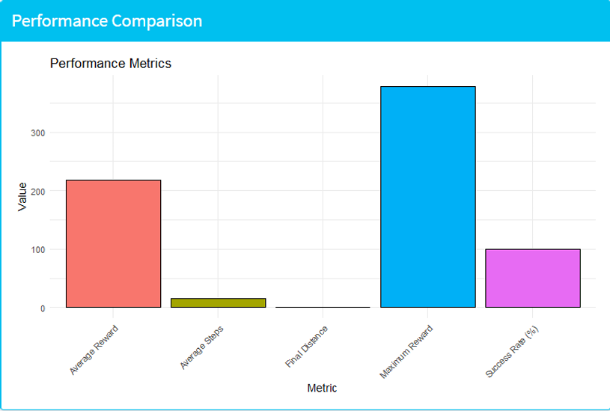
Figure 4.2: Performance Comparison of the Cooperative Drone Swarm

The performance comparison shows that the trained drone agents achieved a 100% success rate with a final distance of 0.00, confirming successful target reaching. The average reward of
217.86 and maximum reward of 378.18 indicate effective learning, while the average of 15.50 steps shows efficient target navigation. Overall, the results demonstrate that the MARL-based approach supports effective cooperative behaviour among drones.

Performance Evaluation

The performance of the proposed cooperative drone swarm is evaluated using average reward, maximum reward, average steps, final distance, and success rate. These metrics measure the effectiveness of the learned behaviour and the overall performance of the cooperative drone swarm.
Metric | Result | Interpretation
Average  Reward | 217.86 | Shows the overall reward achieved by the trained  agents
Maximum  Reward | 378.18 | Shows the highest reward achieved during training
Average Steps | 15.50 | Indicates the average number of steps required to  reach the target
Final Distance | 0.00 | Indicates successful target reaching
Success Rate | 100% | Indicates successful completion of the target-  reaching task

The results demonstrate that the MARL-based cooperative drone system is capable of learning effective navigation behaviour. The successful target reaching, high reward values, and reduced number of navigation steps indicate effective cooperative performance.

Discussion

The simulation and training results demonstrate the effectiveness of combining Multi-Agent Reinforcement Learning with swarm-based agent simulation for cooperative drone navigation. The five-drone simulation produced a total reward of 601.12 and an average final distance of
3.77. The trained swarm achieved an average reward of 217.86, maximum reward of 378.18, average steps of 15.50, final distance of 0.00, and success rate of 100%.
The cooperative movement of the drones demonstrates their ability to navigate towards the target while maintaining coordinated behaviour. The MARL training enables the agents to learn suitable actions through repeated interaction with the environment. The performance results further indicate that the trained agents successfully learned the target-reaching task.
Overall, the results support the proposed approach of integrating MARL with swarm coordination for autonomous search and rescue applications. The system provides cooperative navigation and successful target reaching within the simulated environment.

Comparison with Existing Approaches

The proposed system addresses limitations identified in traditional search methods, single-drone systems, and approaches without effective cooperation. Single-drone systems may provide limited area coverage and require more time for large or unknown search areas. Multiple drones without suitable cooperation may also perform redundant exploration or move inefficiently.

Approach | Covera  ge | Coordination | Learning | Target  Navigation
Traditional  Search | Limited | Limited | No | Convention  al
Single-Drone  System | Limited | Individual | Limited | Individual  navigation
Conventional Multi-Drone | Improve d | Requires coordination | Not necessaril  y adaptive | Cooperativ e  movement
Proposed MARL Drone  Swarm | Improve d | Cooperative | Yes | Learned cooperative  navigation

The proposed MARL-based approach combines multiple learning agents with swarm coordination to support cooperative navigation. The results demonstrate successful target reaching and effective learned behaviour in the simulated environment.

Summary of Results
The developed system successfully generated drone swarm data, performed preprocessing, simulated cooperative drone movement, trained multiple agents using MARL, and evaluated their performance. The simulation with five drones demonstrated cooperative movement towards the target, while the trained swarm achieved a 100% success rate and a final distance of 0.00.
The average reward of 217.86, maximum reward of 378.18, and average steps of 15.50 demonstrate effective learning and target navigation. The results show the potential of combining Multi-Agent Reinforcement Learning with swarm-based coordination for autonomous search and rescue operations.

CHAPTER 5

CONCLUSION, FUTURE WORK AND REFLECTION

Conclusion
The project developed a cooperative drone swarm system for autonomous search and rescue using Multi-Agent Reinforcement Learning (MARL) and swarm-based agent simulation. The system combines multiple independent learning agents with swarm coordination to support cooperative navigation, target detection, search coverage, and safe movement. The methodology included drone data generation and preprocessing, multi-agent swarm simulation, MARL training, and performance evaluation.
The simulation demonstrated effective cooperative movement of the drone agents toward the target. The trained system achieved an average reward of 217.86, maximum reward of 378.18, average steps of 15.50, final distance of 0.00, and a success rate of 100%. These results indicate that the proposed MARL-based approach successfully supports cooperative navigation and target reaching.
Overall, the project demonstrates the potential of combining MARL with swarm-based coordination for improving autonomous search and rescue operations. The approach provides cooperative behaviour among multiple drones while reducing redundant exploration and supporting efficient target navigation.

Future Work
The future development of the project can focus on improving the MARL algorithms and using real-world drone and environmental datasets to achieve more realistic cooperative decision-making. The system can also be extended to more complex search environments containing multiple targets, dynamic obstacles, larger search areas, and realistic collision avoidance, communication, and energy constraints.
Further work can include deploying and comparing the trained system in real-time drone simulation environments with other reinforcement learning and swarm intelligence algorithms. This would provide a broader evaluation of the effectiveness of the proposed cooperative drone swarm approach.

Professional Learning & Individual Reflection
New Knowledge Acquired
    - Understanding of Multi-Agent Reinforcement Learning for cooperative decision-making.
    - Understanding of swarm-based coordination among multiple autonomous drones.
    - Knowledge of drone state representation, including position, velocity, battery and sensor-related information.

    - Experience with reward-based learning for target detection, search coverage, collision reduction and energy efficiency.
    - Understanding of performance evaluation using reward, search steps, final distance and success rate.

Engineering & Professional Skills Developed
    - Problem formulation for autonomous search and rescue systems.
    - Design of multi-agent simulation and cooperative navigation.
    - Data generation, preprocessing and analysis.
    - Reinforcement learning model implementation and evaluation.
    - Interpretation of simulation results and performance metrics.
    - Team-based project development, documentation and technical presentation.

Individual Reflection – N.Parnita (192525322)
Through this project, I gained knowledge about the application of reinforcement learning to autonomous search and rescue operations. The project helped me understand data preprocessing, multi-agent simulation and performance evaluation. A major engineering learning was how reward functions can encourage useful behaviour such as target detection and cooperative navigation while discouraging collisions and unnecessary energy consumption. In a future version, I would work toward using more realistic drone and environmental datasets.

REFERENCES

- T. Hickling, M. Hogan, A. Tammam, and N. Aouf, “Deep Reinforcement Learning Based Autonomous Decision-Making for Cooperative Uncrewed Aerial Vehicles: A Search and Rescue Real World Application,” Journal of Field Robotics, 2026.
- C. Chen, S. Yan, X. Zhou, et al., “Multi-stage Hierarchical Multi-Agent Reinforcement Learning for UAV-Quadruped Completing Search and Rescue,” Discover Robotics, 2026.
- M. Liu, J. Wei, and K. Liu, “A Two-Stage Target Search and Tracking Method for UAV Based on Deep Reinforcement Learning,” Drones, 2024.
- V. Sadhu, C. Sun, A. Karimian, R. Tron, and D. Pompili, “Aerial-Deep Search: Distributed Multi-Agent Deep Reinforcement Learning for Search Missions,” IEEE Conference Proceedings, 2024.
- S. Han, X. Liu, M. C. Zhou, et al., “Joint Association, Deployment and Flight Trajectory Optimization for Multi-UAV Enabled Large-Scale Mobile Edge Computing,” IEEE Internet of Things Journal, 2024.
- S. J. Chung, A. A. Paranjape, P. Dames, S. Shen, and V. Kumar, “A Survey on Aerial Swarm Robotics,” IEEE Robotics and Automation Magazine, 2018.
- L. Gupta, R. Jain, and G. Vaszkun, “Survey of Important Issues in UAV Communication Networks,” IEEE Access, 2016.
- M. Dorigo, M. Birattari, and M. Brambilla, “Swarm Robotics,” Swarm Intelligence, 2014.
- L. Yang et al., “A LODBO Algorithm for Multi-UAV Search and Rescue Path Planning,” Chinese Journal of Aeronautics, 2014.
- Y. U. Cao, A. S. Fukunaga, and A. B. Kahng, “Cooperative Mobile Robotics: Antecedents and Directions,” Autonomous Robots, 1997.

APPENDICES

Appendix A – Detailed Calculations
Include the calculations used in the project, such as:
  - Search Coverage
Search Coverage = (Area searched / Total search area) × 100
  - Target Detection Rate
Target Detection Rate = (Number of targets detected / Total number of targets) × 100
  - Q-value Update
Q(s,a) = Q(s,a) + α[R + γ max Q(s′,a′) − Q(s,a)] Where:
    - α = learning rate
    - γ = discount factor
    - R = reward
    - s = current state
    - a = current action
    - s′ = next state
    - a′ = next action
These equations are part of the documented MARL methodology.

Appendix B – Engineering Drawings / Schematics



The project source includes an architecture showing the search environment, MARL module, swarm coordination module, and performance evaluation.

Appendix C – Source Code / Code Repository Information
https://github.com/Parnita21/MLA0305-REINFORCEMENT-LEARNING/blob/main/Capstone%20-
%20Project%20Horizon/app.R

Appendix D – Datasheets
“Not applicable. The project was developed and evaluated using a simulated drone swarm environment, and no specific physical hardware datasheets were documented.”

Appendix E – Experimental / Raw Data

Drone | Battery | Speed | Target Distance | Status
Drone 1 | 75.18 | 36.03 | 31.06 | Target Detected
Drone 2 | 45.26 | 60.95 | 82.45 | Searching
Drone 3 | 51.84 | 40.50 | 47.03 | Target Detected
Drone 4 | 38.45 | 80.42 | 32.87 | Target Detected
Drone 5 | 46.18 | 71.23 | 12.57 | Searching
The simulation used 5 drones and 50 simulation steps, with an average final distance of 3.77 and total reward of 601.12.
The reported performance results were:
    - Average Reward: 217.86
    - Average Steps: 15.50
    - Final Distance: 0.00
    - Maximum Reward: 378.18
    - Success Rate: 100%

Appendix F – Ethics / Institutional Approval
The project involves the development and simulation of a cooperative drone swarm search and rescue system using Multi-Agent Reinforcement Learning (MARL) and swarm-based agent simulation. The project uses synthetic drone data and a simulated search environment for development, training, and performance evaluation. The documented work does not include any specific ethics approval or institutional approval documentation.
The project documentation states that the work was carried out in accordance with engineering ethics and academic integrity. The sources, data, results, analysis, and findings are intended to be appropriately acknowledged and reported without fabrication, falsification, or manipulation.

Appendix G – Project Meeting / Progress Records

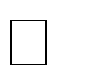

Generation of synthetic drone swarm data. Data preprocessing and normalization.

Development of the cooperative drone swarm simulation.


Implementation of swarm coordination using separation, cohesion and alignment. Development of the Multi-Agent Reinforcement Learning (MARL) model.

Implementation of cooperative reward calculation.


Performance evaluation using reward, search steps, final distance and success rate. Analysis and documentation of the obtained results.
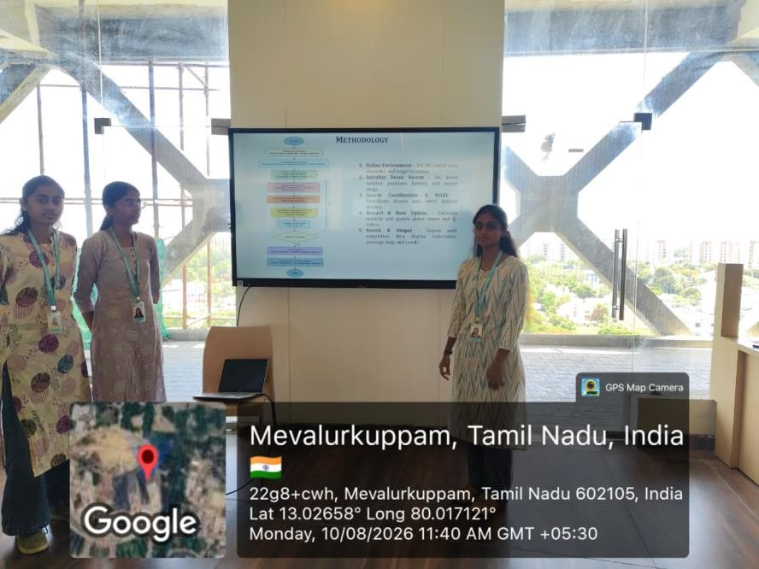

Appendix H – User/Industry Feedback
The project focuses on developing a cooperative drone swarm system for autonomous search and rescue using Multi-Agent Reinforcement Learning (MARL) and swarm-based agent simulation. The available project report and presentation describe the system methodology, simulation, performance evaluation and results, but do not contain documented feedback from external users, industry personnel, rescue organizations, or other stakeholders.
The system was evaluated using technical performance measures including search coverage, target detection, average reward, search steps, final distance and success rate. The reported results demonstrate the effectiveness of the proposed cooperative approach within the simulated environment.

Appendix I – Publications / Patents / Competitions / Product Outcomes
The project developed a cooperative drone swarm search and rescue system using Multi-Agent Reinforcement Learning (MARL) and swarm-based agent simulation. The project documentation

presents the methodology, algorithms, simulation results, performance evaluation and future scope of the proposed system.

The available project source files do not document any completed publication, patent, competition participation or product outcome resulting from this project.

Appendix J – Individual Contribution Evidence

Student Name /  Register No. | Project Contribution Area
P. Hithaishi –  192425196 | Contribution to the development and documentation of the  cooperative drone swarm search and rescue project
K. Sri Lasya –  192472216 | Contribution to the development, analysis and documentation of  the MARL and swarm-based simulation approach
N. Parnita –  192525322 | Contribution to data generation, preprocessing, performance  evaluation and project documentation

The overall project work included synthetic drone swarm data generation, data preprocessing, cooperative drone simulation, swarm coordination, Multi-Agent Reinforcement Learning, cooperative reward calculation, performance evaluation and documentation of the results.

